

School of Electronic Engineering and Computer Science

FINAL YEAR PROJECT REPORT

Project Title
An Agent-Based Simulator for Analysing Emergent Behaviour in Social Opinion Dynamics

Program of Study
Computer Science

Supervisor
Edon Kelmendi

Student Name
Adam Ornoch

Abstract
…

TABLE OF CONTENTS

Chapter 1: Introduction
1.1 Background
1.2 Problem Definition
1.3 Objectives
1.4 Research Questions
1.5 Report Structure
Chapter 2: Literature Review
2.1 introduction
2.2 Agent-Based Modelling
2.3 Opinion Dynamics
2.4 Classical Opinion Dynamics Models
…
Chapter 3: Analysis & Design
3.1 Requirements Analysis
3.2 Software Development Life Cyle
3.3 Risk Register
Chapter 4: Implementation
Chapter 5: Extra
5.1 References
5.2 Project Plan
5.3 Supervisor Presentation Notes
5.4 Presentation Slides

Introduction

Background
Multi-agent systems (MAS) are computational systems composed of autonomous entities that interact locally with each other and their environment. Research in this area has demonstrated that such local interactions can give rise to complex and often unpredictable global patterns, a phenomenon known as emergent behaviour. A prominent application of this is the study of opinion dynamics, which examines how opinions form, spread, and evolve within populations. With the continuous influence of digital communication, understanding how opinions evolve has become increasingly important, particularly in online environments where interactions can rapidly impact both consensus and polarisation. It is therefore important to examine the extent to which different factors shape the spread of opinions.

Problem Definition
Extensive research has been done on opinion dynamics, including in depth-theory and computerised modelling. Two prominent examples are the Hegselmann-Krause (HK) bounded confidence model and the Deffuant-Weisbuch (DW) model, both of which provide valuable theoretical frameworks for understanding how consensus, polarisation, and fragmentation emerge from local agent interactions. While these models are well-studied in the literature, their implementations are often static, technically inaccessible, and limited in scope – not offering much for real-time exploration or visual inspection of emergent behaviour.
Many existing simulation tools suffer from limitations including a restricted set of configurable parameters, lack of interactive visualisation, and restriction to a single agent interaction rule. This limits the range of conditions that can be compared and makes it difficult to intuitively understand how changes in agent behaviour and environment result in population-wide outcomes. Furthermore, many implementations assume homogeneous agent populations, ignoring the impact that factors such as stubborn minorities, external broadcasters, and varying interaction strategies have on emergent behaviour.
This project aims to address these limitations by developing a well-rounded accessible platform for real-time interaction, visualisation, and experimentation with agent-based opinion dynamics. It aims to provide a general agent-based opinion dynamics modelling system that supports a wide range of configurable parameters enabling both empirical analysis and visual observation of emergent behaviour

Objectives
The objectives of this project are:
- Design and implement an agent-based opinion dynamics model on a two-dimensional Moore grid, supporting continuous, binary and ternary opinion types.

- Develop an accessible interactive simulator enabling real-time visualisation and parameter configuration for opinion dynamics.

- Extend the base model with configurable agent interaction parameters including confidence threshold, convergence multiplier, and opinion bias.

- Implement and compare three agent interaction rules – single neighbour, full neighbourhood averaging, and a distance-weighted variant.

- Implement stubborn and broadcaster agent types and investigate their influence on emergent population behaviour.

- Implement a systematic parameter sweep system with replication support for empirical analysis of convergence, polarisation, and fragmentation across a user-defined parameter space.

- Evaluate simulation results against theoretical predictions from the Deffuant-Weisbuch and Hegselmann-Krause models.

Research Questions
This project is guided by the following research questions:
RQ1: Confidence Threshold and Convergence – How does the confidence threshold affect the speed and outcome of opinion convergence?
RQ2: Interaction Rules – How do the three implemented interaction rules differ in convergence speed, clustering patterns and sensitivity to the confidence threshold?
RQ3: Stubborn Agents – What is the effect of stubborn agents on the population’s ability and speed to reach consensus and is there a critical stubborn fraction below which consensus remains achievable?
RQ4: Opinion Bias and Initial Conditions – How does the initial opinion distribution affect the direction and final state of opinion convergence and to what extent can this be influenced by the presence of stubborn or broadcaster agents?
RQ5: Broadcast Agents – To what extent can broadcaster agents shift majority opinion and how effective are they considering different confidence thresholds, convergence multipliers, and the presence of stubborn agents?
RQ6: Opinion Type – How does restricting agents to discrete opinion types affect emergent behaviour compared to continuous opinions?

Report Format

Literature Review

2.1 Introduction

2.2 Agent-Based Modelling
Agent-Based Modelling is a simulation approach used to study complex systems through autonomous interactions of individual entities known as agents. Each agent is assigned a set of behavioural rules governing how it interacts with other agents and its environment. When many agents function under these local rules, complex global patterns can emerge at the population level, known as emergent behaviour, without any central controller.
A fundamental demonstration of this is Reynolds’ (1987) Boids simulation, in which agents following just three simple rules (separation, alignment, cohesion), produced realistic bird flocking behaviour. This illustrates a foundational principle that simple agent rules can lead to complex emergent behaviour.
This bottom-up approach makes ABM suitable for modelling social phenomena such as opinion dynamics. In the real world, opinions are formed through countless local interactions between individuals through conversations and social media exchanges. ABM naturally reflects this structure, making it well suited for studying how population-level outcomes such as consensus, polarisation, and fragmentation emerge from individual-level behaviour

2.3 Opinion Dynamics
Opinion dynamics is the study of how individual beliefs evolve over time through social interaction. It focuses on trying to understand the processes that drive opinion change - how agreement spreads, how disagreement persists, and how a population can converge to a shared view or split into different groups. Computational modelling has become a key tool for studying these processes, as it allows researchers to run controlled experiments, isolate the effect of each variable, and observe population-level behaviour.
Understanding opinion dynamics in the context of modern society becomes increasingly important. The growth of social media platforms has sped up information exchange and has significantly increased the influence of global communication. A real-world example is the study of political polarisation on Twitter. Bail et al. (2018) conducted an experiment through Twitter where participants were exposed to opposing political viewpoints for a short duration of time, and their political standing was measured before and after. The findings were surprising in that rather than reducing polarisation, exposure to opposing views actually increased it – a counterintuitive result that highlights the complexity and importance of opinion dynamics. Similarly, the spread of vaccine hesitancy during the COVID-19 pandemic demonstrated how a stubborn minority opposing vaccinations publicly could resist convergence despite the majority holding opposing views. This is directly relevant to the stubborn agent dynamics explored in this project.
Three key outcomes are of primary interest in opinion dynamics research:
Consensus refers to the state where all agents in a population converge to a single shared opinion. This typically occurs when agents are open to influence from those with differing views. In bounded confidence models, where agents will only converge to others’ opinions if they are within a given range, consensus is generally achieved with a high enough confidence threshold.
Polarisation describes a state in which the agent population splits into distinct groups with opposing opinions. It often arises when agents are only willing to interact with others whose views are quite close to their own.
Fragmentation occurs when the population separates into many small clusters of similar opinion agents. This is typically achieved with very low confidence thresholds, where agents are only influenced by other agents with a very similar opinion to their own.
These three outcomes form the basis for evaluating simulation results throughout this project. The following section examines two influential models of opinion dynamics - the Deffuant-Weisbuch and Hegselmann-Krause models, both of which are directly implemented and extended within this project.

2.4 Classical Opinion Dynamics Models

2.4.1 The Deffuant-Weisbuch Model
Deffuant et al. (2000) introduced a continuous opinion dynamics model in which a population of n agents each hold a real-value opinion x_i taken between [0, 1]. At each time step, a randomly selected pair of agents from all the agents, interact through comparing their opinions. If their opinion difference falls below a specified confidence threshold value d, both agents readjust their opinions towards each other according to the following rule:
x_i = x_i + μ(x_j – x_i)
x_j = x_j + μ(x_i – x_j)
where μ ∈ [0, 0.5] is the convergence multiplier dictating how much each agent’s opinion converges towards the others.
A key finding of the study is that μ and the population size n only influence the speed of convergence, whereas the confidence threshold d influences outcome of the simulation. High d values lead to full consensus as agents were willing to interact with a wide range of opinions, whilst lower values of d produce polarisation and eventually fragmentation into many opinion clusters. This establishes the confidence threshold as the most impactful parameter in this bounded confidence opinion dynamics model.
Deffuant et al. (2000) extend their study to examine the impact of locality. They now place agents on a 2D Von Neumann grid, meaning that each agent has 4 distinct neighbours that it can interact with (North, East, South, West). When tested, the model produced distinct clustering behaviour particularly at low confidence thresholds where lone extremist agents (with opinions close to 0 or 1) and small isolated clusters emerge. The researchers observe that even at this level of simplicity, spatial clustering occurs consistently, concluding that such patterns should be expected in more complex models and even in real-world environments such as in politics.
This model is directly relevant to this project in several ways. First, the single neighbour interaction rule implemented in this simulator closely follows the DW interaction mechanism, where at each step, each agent selects one random neighbour and if their opinion difference falls within the confidence threshold, the agent’s opinion moves towardsthat neighbour’s opinion by a factor of the convergence multiplier μ. Second, the agents are placed on a 2D Von Neumann grid and this simulator places agents on a Moore grid which increases each agent’s neighbour count from 4 to 8 (now each agent also has neighbours in the closest NW, NE, SW, SE cells). Third, the finding that d is the primary parameter of the simulation outcome directly motivates the confidence threshold as the most significant parameter in the experimental analysis conducted in Chapter 5.
One notable difference between the original DW model and this project’s implementation is that in the DW agent interactions both agents converge their opinions towards each other, whereas in this simulator only one of the agents update their opinion. This is a deliberate design choice that more closely models asymmetric real-world communication, where one individual may speak while the other listens without the speaker being influenced in return. This distinction is acknowledged and its implications for convergence behaviour are discussed in Chapter 6.

The

Analysis & Design

3.1 Requirements Analysis

Functional Requirements:
- The system will simulate multiple autonomous agents that can interact with each other.
- Each agent will follow a set of local rules.
- Emergent behaviours can be deduced through analytics or 2D/3D modelling as they arise.
- The system will have adjustable parameters for the simulations.
Non-Functional Requirements:
- The system should handle simulations with 100 agents.
- The framework should allow for additional agent rules to be added.

3.2 Software Development Life Cycle

I have chosen an iterative SDLC for this project due to the exploratory nature of emergent behaviour. System behaviour cannot be predicted in advance, therefore the project must be developed and improved through successive iterations, refining agent rules and observing outcomes.
This approach reduces development risk that a linear development model might have. This would include assuming requirements which may end up being incorrect, resulting in the system not being developed in the correct direction.

Below I have illustrated an iterative design process that I will follow:
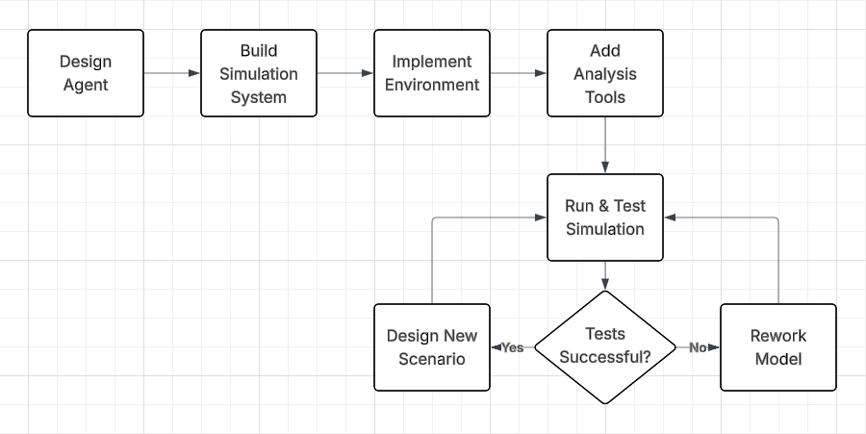

3.3 Risk Register
Risk Description | Likelihood | Impact | Risk Level | Mitigation Strategy
Emergent behaviour deviates from intended outcome | High | Medium | High | Define constraints on agent rules, test with small population first
Performance degrades with increasing agent numbers | Medium | High | High | Limit agent count, optimise code complexity
Emergent behaviour fails to appear | Medium | Medium | Medium | Introduce adaptive parameters or mutations
Simulation results are difficult to validate or explain | Medium | Medium | Medium | Define measurable metrics, collect statistical data, re-run simulations
Scaling emergent behaviours fails | Medium | High | High | Incrementally scale agent count and validate findings at each stage
Project scope becomes too large due to complex agent interactions | Medium | Medium | Medium | Clearly define system boundaries and emergent goals early

Extra

5.1 References

- Reynolds, Craig W. (1987) Flocks, Herds, Schools: A Distributed Behavioral Model. Available at: https://dl.acm.org/doi/pdf/10.1145/37402.37406

- Han, T.A (2022) Emergent behaviours in multi-agent systems with Evolutionary Game Theory. Available at: https://journals.sagepub.com/doi/full/10.3233/AIC-220104

- Martinez-Gil, Francisco et al. (2017) Emergent behaviors and scalability for multi-agent reinforcement learning-based pedestrian models. Available at: https://www.sciencedirect.com/science/article/pii/S1569190X17300503

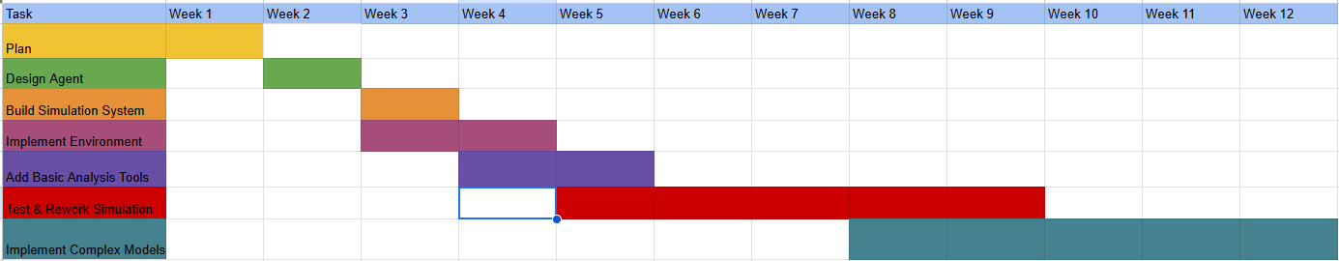
5.2 Project Plan

5.3 Supervisor Presentation Notes
- Focus on the project system over focusing on an individual simulation, showing that this project can do many things, delve into many branches, have many uses.

- Link the project to Game Development or Computer Graphics as these are modules I have completed. I can achieve this by designing simulations that explore these areas.

5.4 Presentation Slides
